CLIMATE CHANGE AND THE SWITCH TO CLEAN ENERGY
PART A
Carbon dioxide levels in the atmosphere today are higher than at any point in at least the past 800,000 years. The risks associated with the resultant climatic change have been well documented.
We can model the problem of climate change as a game between two groups: developing nations and developed nations. In this game, each group can choose from one of two possible climate strategies:
- Abate: governments enact policies to reduce carbon emissions, for example, by subsidising clean energies or taxing fossil fuels.
- No change: governments fail to enact policies to reduce carbon emissions. Businesses and individuals are free to pursue their own self-interest.
The outcomes and payoffs of this game are shown in Figure 1 below.
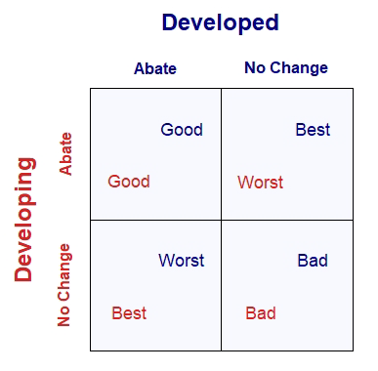
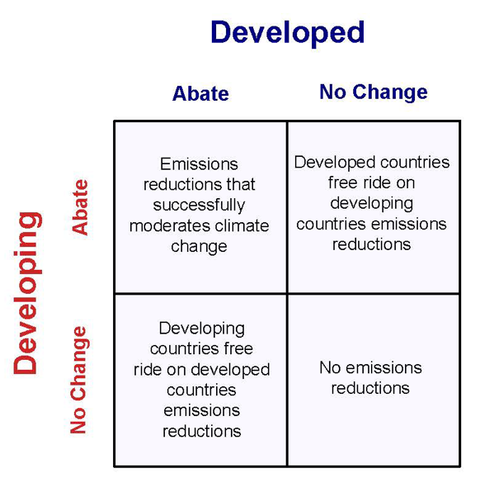
Figure 1: Outcomes and payoffs for the climate strategy game.

Question 1
What is the Nash equilibrium of the game shown in Figure 1? Show the steps you took to reach this conclusion. Is this Nash equilibrium a prisoners’ dilemma? Why or why not? [2 marks] [max words: 100]
Question 2
Suppose there is a change in social preferences in both developing and developed nations. Figure 2 shows the new payoffs for the climate strategy game in this case. What are the Nash equilibria of this game? Show the steps you took to reach this conclusion. [2 marks] [max words: 100]
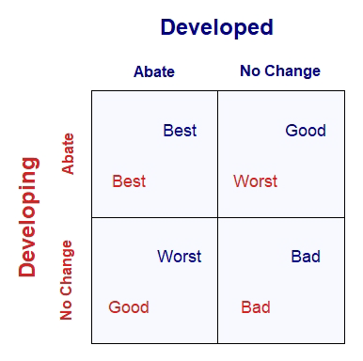
Figure 2: Payoffs for the climate strategy game with social preferences.

Question 3
The ideal outcome for the climate strategy game is one in which a dominant strategy equilibrium is achieved when both groups of countries choose to abate emissions. Explain how a change in the rules of the game could lead to a potential solution to the social dilemma of climate change. [3 marks] [max words: 200]
PART B
Emissions reduction treaties between nations have been proposed as a key method with which to tackle climate change and its negative impacts. One such treaty is the Paris Agreement. Adopted by 197 nations in 2015, the deal aims to substantially reduce carbon emissions and to limit the global temperature increase in this century to 2 degrees Celsius.
A summary of the Paris Agreement can be found here.
The Paris Agreement includes commitments from all nations to reduce their emissions and work together to adapt to the impacts of climate change and calls on a strengthening of commitments over time. The agreement provides a pathway for developed nations to assist developing nations in their climate mitigation and adaptation efforts. Nations can set their own ‘nationally determined contributions’ towards emissions reductions that reflect their capabilities, level of economic development, and contribution to emissions over time.
Question 4
Binding treaties to abate emissions between groups of nations are often difficult to achieve. Explain why this is the case. You must cite at least one reputable source from your own research. Include the full reference at the end of your answer, which will not count towards the word limit. Use a standard referencing system (e.g. Harvard style). [3 marks] [max words: 200]
Question 5
Discuss three reasons why the Paris Agreement treats developing nations differently from developed nations. You must cite at least one reputable source from your own research. Include the full reference at the end of your answer, which will not count towards the word limit. Use a standard referencing system (e.g. Harvard style). [3 marks] [max words: 200]
Question 6
Evaluate the decision to distinguish between developed and developing nations in the Paris Agreement from the perspective of substantive and procedural judgements of fairness. Be sure to define both judgements of fairness in your answer. [5 marks] [max words: 500]
Question 7
The Paris Agreement is based on voluntary carbon emissions reduction pledges made by participating nations. Using either a consequentialist or a deontological framework, discuss if it would be ethically acceptable to legally impose these emission reduction pledges and enforce these goals with penalties? Explain your reasoning. Be sure to define your chosen ethical framework in your answer. [5 marks] [max words: 500]
PART C
Moving a nation’s source of power from fossil fuels (such as coal) to clean energy sources (such as solar) can reduce carbon emissions.
Suppose the price of a unit of coal (PC) is $50 and the price a unit of solar (PS) is $30. A representative power plant can use a mixture of coal and solar inputs to produce one unit of electricity.
The power plant has two types of technologies available to them to produce one unit of electricity:
Coal (C) Solar (S)
Technology A 10 units 2 units
Technology B 3 units. 20 units
Assume that the power plant uses no other inputs in its production process.
Question 8
Calculate the production costs required for the two types of technology to produce one unit of electricity. Show your workings. Which technology would the power plant choose? [2 marks] [max words: 100]
Question 9
Using an isocost diagram, model a change in relative prices that would incentivise a shift in technologies from the choice you indicated in your answer to Question 8. On your diagram, be sure to state the new prices and include all isocost lines (before and after the change in prices). Label the intercepts and slopes of the isocost lines and show the resultant choice of technologies, along with their associated quantities before and after the change in prices. Calculate the innovation rent that arises due to this switch in technologies, show your working. [10 marks] [max words: 100]

